**AUTOMATED ATTENDANCE USING FACE RECOGNITION**

**PROJECT REPORT**

**TEAM 15**

|  |  |
| --- | --- |
| **STUDENT NAME** | **STUDENT ID** |
| YAMINI MANGARAI | 11535594 |
| SAI BHARATHI DURGA GUNTUPALLI | 11584514 |
| ANIRUDH BUSSA | 11563583 |
| TEJA GOUD SURIGI | 11566610 |

**SUBMITTED TO:**

**Dr. Anna Sidorova**

**BCIS 5140 - ARTIFICIAL INTELLIGENCE**

**FALL 2022**

**DECEMBER 7, 2022**

**TABLE OF CONTENTS**

**CONTENTS PAGE NUMBER**

EXECUTIVE SUMMARY 3

CLIENT ORGANIZATION 4

PROBLEM DESCRIPTION 5

SOLUTION DESCRIPTION 6

SOLUTION DATA REQUIREMENTS 7

ACQUISITION STRATEGY 8

UNDERLYING ML MODEL REQUIREMENTS 10

SOLUTION ARCHITECTURE 12

PROTOTYPE 14

REFERENCES 17

**EXECUTIVE SUMMARY**

In this project we are going to propose Automated Attendance marking using Face Recognition during examinations**.** Attendance is important in every part of the world’s educational institutes for students and Faculty. Attendance is normally taken by manual or automated system. The manual is by passing the sheet to the students or calling out each student's name in the crowded class and marking the attendance. It may be during exams or everyday class. Automated at some institutes are using fingerprint based or by iris-based attendance marking which have drawbacks and are also expensive.

When we have a lot of development in educational institutes digitally and why can't we make attendance also automated by using non-contact method and efficient way to mark daily in an easy and fast way where we get the report automatically in the system. Normally the attendance, if it is manual the report should be maintained by the lecturer in the book for every student and the data is not stored anywhere except in the book. However, it can be time-consuming and prone to mistakes made by humans.

Using face recognition, we can keep a report track of students for future reference, during examinations there is less time taking, the main thing is to avoid proxy. Input information will therefore be gathered from student faces at the time of enrolling and stored in the database. At the time of the attendance in the class, the lecturer will capture the image through a surveillance camera of the class where the face recognition is done, and the attendance is marked automatically in the system. By using HAAR Cascade algorithm detection is done, integral images and Adaboost are used as classifiers.

**CLIENT ORGANIZATION / INDUSTRY DESCRIPTION**

The current procedure for recording attendance in educational institutions around the world involves the faculty using manual attendance like calling on each student individually or passing a sheet if there are a lot of students present during examinations. The attendance is either taken on canvas by calling out each student's name or by giving a sheet to the entire class, as shown by using University of North Texas as our client.

With a set number of daily tasks, most professors and staff struggle with time management and avoid proxy during examinations. Through this project we are proposing the use of face recognition to capture attendance during exams. With this approach we can avoid human errors and data collected by the system will be more accurate and less time-consuming. Attendance is important for students, which helps to improve their performance with fairness among students.

**PROBLEM DESCRIPTION**

Nowadays attendance is taken in a manual way on a sheet of paper or by calling out each student’s name and entering in the system by faculty, this procedure is time consuming and risk of proxy. It is difficult to call out to each student in a large classroom. This also causes much disturbance during examinations. Maintaining the records of attendance is difficult for the faculty. During the examination the faculty takes a picture on the smartphone as a proof of that students who were present, with this faculty needs to recheck later or checks when needed but there will not be any proof or attendance marking report who wrote the exam, this is again a manual process. The data of the student’s attendance report will not be stored and cannot say that may be accurate, anyone can mark as present in class for their friends. There are some automated attendance systems being used in some institutions like iris based, which have drawbacks like deploying a camera for iris scanning is very high when compared to normal camera, another disadvantage would be person need to go close to camera for the scanning. This might be uncomfortable for some students, whereas in face recognition with just with a click of the image the attendance will be marked for the students. Face recognition attendance marking will not only be useful for educational institutions, but it will also be helpful in corporate offices for the employees for attendance marking in a matter of seconds.

**SOLUTION DESCRIPTION**

**1. Overall description of the solution**

Our proposed solution is automated attendance marking using face recognition during examinations, where the student at the enrollment time uses face detection on myunt portal and gives the data of their face detection and which is stored and then the faculty uses canvas where the data of the student appears and loads automatically, through surveillance camera faculty captures the picture of the class and with that the captured image and data stored face matching is done and then the attendance is marked in canvas and the report is generated.

**2. What does solution do? What process does solution serve?**

This solution gives the attendance using face recognition by just capturing the image of the class by faculty. With this solution attendance is easy to take and helps during exams to avoid proxy and time saving process.

**3. Who are the users of the solution? How do they use the solution?**

The users are the faculty of educational institutions. Faculty of UNT use this attendance system through canvas by capturing the image and marking attendance automatically.

**4. What are data inputs into the solution at the runtime (once implemented)?**

The data inputs are the images of the students which are already in the system which are taken during the enrollment and saved in the database in myunt.

**5. What are the outputs of the solution? Who uses these outputs? Are they used as an input into a different system?**

The output after capturing the image by faculty through canvas the attendance gets marks and report gets generated. Faculty uses these outputs to give grades to the students, to see the class participation etc. It is used to get the attendance that who were present for the examination.

**6. What component of the solution can be described as AI and why?**

The components of this solution can be described in four important components which are, student registration - face detection - face recognition - attendance management system. They are an important feature to get the process of solution to work.

**SOLUTION DATA REQUIREMENTS**

**1. What data will need to be provided for developing the solution? Think about training data.**

The data that need to be provided for developing the solution is the images of the students at the time of student registration on the myunt portal with student information where all the images are being saved as a training data set for face detection process.

**2. What data inputs will the solution use at the runtime? Think about the data used for scoring/during runtime solution.**

Images of students are saved in the portal with student information at registration and at the time of solution the faculty use canvas to capture the image of the class to get the attendance marked with a surveillance camera. So, the image captured at the time of attendance is the input taken at runtime for a solution to mark the attendance.

**3. What are the quality requirements on the data vs. existing data quality?**

To get the output the phase of extraction takes the input as images and features are extracted for each student. Each face has a pattern where the accuracy and validate in the measuring distance and it extracts the unique facial features from the captured image from the class. Where it classifies the facial features and recognizes the pattern and generates the image.

**4. Data transformation pipeline requirements?**

The requirements for the data transformation are image capture of students then convert the original image to gray scale which detects the face and recognition of face is done when faculty captures the image and attendance is marked from the data stored.

**ACQUISITION STRATEGY / PLATFORM REQUIREMENTS**

**Will your solution be using  AI Cloud APIs? Why is this the best solution?**

We are not using any of the cloud APIs. But to get data from the database to the front end, we need to develop our own API calls. An API acts as an interface between both frontend and backend. With Application Programming Interface the data from the database can interact with the web application in a structured format. We can develop our API calls in any language. One of the best ways to create application programming interfaces is by using dot net framework and language used is C#.  It is the best solution because by creating our own API’s we will not have any copyright issues. We may use some of the built-on API’s like AWS, Clarifai they are a bit expensive. Instead, we can develop our own APIs and use them

**AI Platform/proprietary algorithm? Why is this the best solution?**

For face detection the algorithm used is Viola Jones

**Viola Jones Algorithm**

This algorithm was developed by two researchers “Paul Viola and Michael Jones” in their research paper. This algorithm has four main steps

1. Haar like features selection
2. Integral image creation
3. Training Adaboost
4. Haar cascade classifiers

**1. Haar like features selection**

These are characteristics of digital images that are useful for identifying faces in pictures. There are certain rules universally implemented for facial detection like brightness and darkness. For instance, the eye region is darker than the neighbor’s pixels. It detects the brighter regions in the object by using three main features, edge and line features are used to find the edges and line of the object and for finding the diagonals four sided features.

**2.Integral image creation**

It is used in calculating the summation of the pixels. On each and every haar feature we perform some calculations on the pixels. These calculations are a bit time consuming. They must check which feature is useful in certain areas and for pixels calculation.

**3.Training Adaboost**

A base window of 24x24 window is used by viola jones algorithm to detect features in the image. In a window approximately 160000+  haar features can be calculated in total. It focuses only the haar features detection like on the nose, eyes, chin etc. Some of the features can be ignored which are not important.

**4.Haar Cascade Classifiers**

An image might have more than one face. The main aim of viola jones algorithm is once an image is taken it scans the entire image from top to bottom. It focuses mainly on face regions. There will a many number of stages. In each stage, the algorithm checks the face regions in any stage the face is not found it simply discards that stage and performs another operation.

**Why is this the best solution?**

Even Though this algorithm takes lot of time to train data, but this works very well in detection of faces based on the studies.

For face recognition, we are using the eigen faces approach, for feature extraction and dimensionality reduction principal component analysis is used.

**UNDERLYING ML MODEL REQUIREMENTS**

**1. Is your AI ML based? If not, explain why it is AI. Explain what AI components that are non-ML based are present.**

Yes, our AI is machine learning based. We are using viola jones algorithm which is used for object detection in machine learning framework. The below are the few components:

* Detection
* Comparing
* Recognition

**2. For ML-based AI, what will be the role of the ML model? Describe the model in terms of the target variable and the algorithm used. Describe the algorithm with references**

The role of ML model is to train the data by using images and evaluate them for marking the attendance to students automatically without human intervention. Target variable would be an image captured by the instructor in the classroom and comparing them against the images at the time of registration.

Viola Jones is an algorithm, which is used for detecting faces, eigenfaces approach is used for face recognition, feature extraction, dimensionality reduction the approach we are following would be principal component analysis.

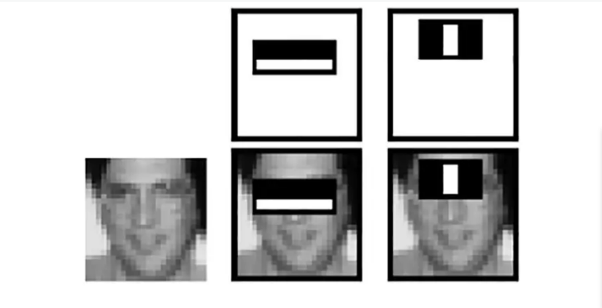

**Haar features**

**3. Define performance criteria for determining that the model is fit for use. Accuracy, precision/recall, R-sqrd, MAPE?**

The performance criteria for our model are determined based on accuracy. For recognizing the images from the data stored the image captured in the class should recognize the face 99.97% accurately. Then the existing fingerprint system face recognition matches more data, as we have secured data stored and only few percentage of people will get to use fingerprint. By using face recognition images are captured and, we can track the data anytime by administration.

**SOLUTION ARCHITECTURE**

**Triggers/data inputs**

The input would be image captured by the camera in the classroom

**Pipelines and data transformation**

**Image Capture**: The image needs to be taken by the camera

**Convert Original Image to Gray Scale**

The original image captured needs to be converted into gray scale image i.e., like black and white so that there can be increase in contrast. It becomes easy for the algorithms to detect the features of the image.

**Face Detection**

Once the image is captured, the face needs to be detected. By using viola jones face detection algorithm faces are detected. Also called Haar Cascade Classifier. In this project, we are using integral images and Adaboost as classifiers.

**Face Recognition**

Face recognition tells whose face it is. By checking the landmarks of the face data that is stored previously in the training set. By using some techniques like principal component analysis face recognition and feature extraction is done. Eigen faces approach is followed because it is one of the best approaches to reduce the dimensions of the data.

Eigen vectors and eigen values are used in reducing the size of the image, it is the best approach for reducing the dimensionalities.

**Attendance**

The faces are matched against both the training and testing data. If any of the data matches the attendance is marked by the system automatically without human intervention.

**Data/model storage**

The data needs to be stored in a database. The individual images of the students at the time of registration need to be stored in one place named as training set. The images captured by the camera in the classroom for the attendance marking need to be stored in the same database named testing folder.

**Outputs/integration with downstream process**

The output will be automated attendance marking for the students

**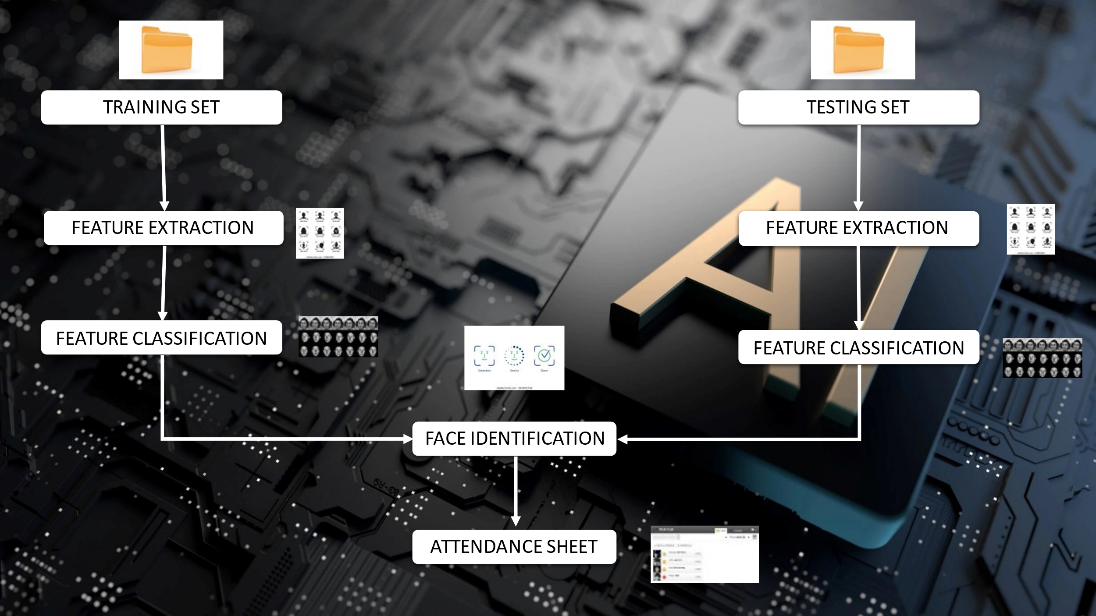

**PROTOTYPE DEMO**

**Which of the components have you prototyped? Describe your prototype and include any screenshots necessary**

We will use our client, UNT, to illustrate how our prototype works (University of North Texas). The first step is for the student to log into MyUNT during registration and choose the face detection option to save their image in the database for attendance. The instructor in the classroom then logs into Canvas, takes a picture of the classroom using the camera, sends it to the system, where face recognition is performed, and Canvas automatically records the attendance.

Main components of prototype:

1. Student Registration
2. Face Detection
3. Face recognition
4. Attendance management system

**Student Registration:**

**Student Logging into myunt at the time of registration.**

**Face Detection**

On the below screenshot the student chooses the option of face detection and setting of camera is performed**.**

On the below screenshot student clicks on the camera and takes a picture.

          Here, an image of a student is being detected and being saved in the record.

**Recognition and Attendance Management system**

The faculty logs into the system at the start of class, during an exam, or daily, and takes a picture of the class using a camera. The process of image and face recognition is then completed using the data already saved in the system, and the system automatically marks the students as present on the canvas.

**REFERENCES**

* [**https://www.slideshare.net/JigarPatel597/face-recognition-attendance-system-222714452**](https://www.slideshare.net/JigarPatel597/face-recognition-attendance-system-222714452)
* [**https://www.ijeat.org/wp-content/uploads/papers/v8i3S/C11230283S19.pdf**](https://www.ijeat.org/wp-content/uploads/papers/v8i3S/C11230283S19.pdf)
* [**https://ijirt.org/master/publishedpaper/IJIRT151654_PAPER.pdf**](https://ijirt.org/master/publishedpaper/IJIRT151654_PAPER.pdf)
* [**https://www.geeksforgeeks.org/ml-face-recognition-using-eigenfaces-pca-algorithm/**](https://www.geeksforgeeks.org/ml-face-recognition-using-eigenfaces-pca-algorithm/)
* [**https://www.edenai.co/post/top-10-face-detection-apis#:~:text=The%20Detect%20API%20detects%20human,to%20identify%20or%20verify%20faces**](https://www.edenai.co/post/top-10-face-detection-apis#:~:text=The%20Detect%20API%20detects%20human,to%20identify%20or%20verify%20faces)**.**
* [**https://levelup.gitconnected.com/haar-like-features-seeing-in-black-and-white-1a240caaf1e3**](https://levelup.gitconnected.com/haar-like-features-seeing-in-black-and-white-1a240caaf1e3)
* [**https://www.slideshare.net/ShreyaDandavate/face-recognition-attendance-system-96913577**](https://www.slideshare.net/ShreyaDandavate/face-recognition-attendance-system-96913577)
* [**https://troindia.in/journal/ijcesr/ijcesr/paper13.pdf**](https://troindia.in/journal/ijcesr/ijcesr/paper13.pdf)
* [**https://ph01.tci-thaijo.org/index.php/jait/article/view/243454**](https://ph01.tci-thaijo.org/index.php/jait/article/view/243454)
* [**https://www.ijstr.org/final-print/feb2020/Smart-Attendance-System-Using-Cd-lbp-Algorithm.pdf**](https://www.ijstr.org/final-print/feb2020/Smart-Attendance-System-Using-Cd-lbp-Algorithm.pdf)
* [**https://www.cs.cmu.edu/~efros/courses/LBMV07/Papers/viola-cvpr-01.pdf**](https://www.cs.cmu.edu/~efros/courses/LBMV07/Papers/viola-cvpr-01.pdf)
* [**https://medium.com/nerd-for-tech/face-detection-recognition-how-machine-learning-approaches-and-algorithms-make-it-possible-4b5896aefb88**](https://medium.com/nerd-for-tech/face-detection-recognition-how-machine-learning-approaches-and-algorithms-make-it-possible-4b5896aefb88)
* [**https://en.wikipedia.org/wiki/Viola%E2%80%93Jones_object_detection_framework#:~:text=The%20Viola%E2%80%93Jones%20object%20detection,Paul%20Viola%20and%20Michael%20Jones**](https://en.wikipedia.org/wiki/Viola%E2%80%93Jones_object_detection_framework#:~:text=The%20Viola%E2%80%93Jones%20object%20detection,Paul%20Viola%20and%20Michael%20Jones)
* [**https://ijettjournal.org/assets/year/2015/volume-22/number-8/IJETT-V22P275.pdf**](https://ijettjournal.org/assets/year/2015/volume-22/number-8/IJETT-V22P275.pdf)
* **https://biometrictoday.com/25-advantages-disadvantages-iris-recognition/**
* **https://unt.instructure.com/login/ldap**
* [**https://my.unt.edu/psp/ps/?cmd=login**](https://my.unt.edu/psp/ps/?cmd=login)